Course Name | ITD 2343 – Object Oriented Programming with C#
Instructor | Mark L. Pranger
Student Name | Lauren Lashley
Due date | February 22, 2026
Grade | <grade earned here>
Grading Comments | <instructor comments here>

Week 7 – Programming Lab

Screenshot 1: show after UI design completion.
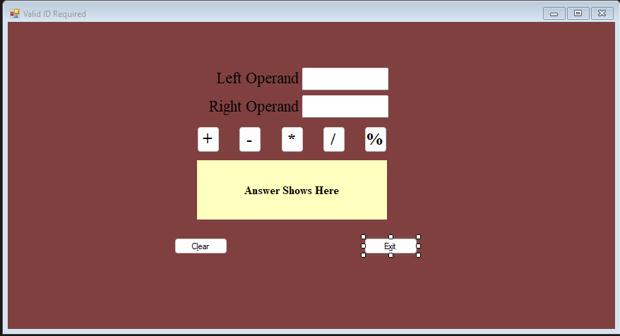

Screenshot 2: show the domath code for the validation setup:
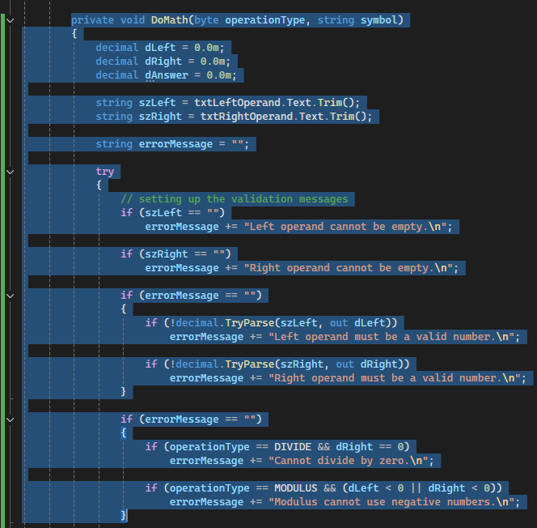
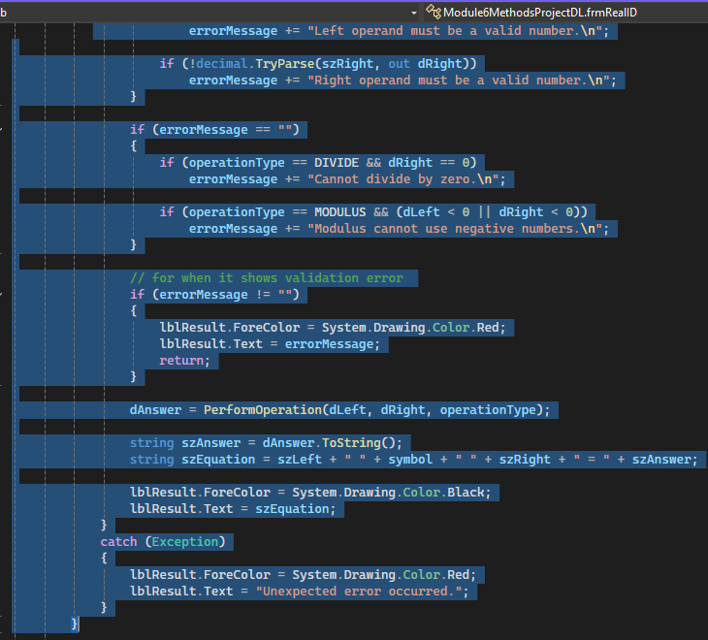

Screenshot 3: show app in debug mode:
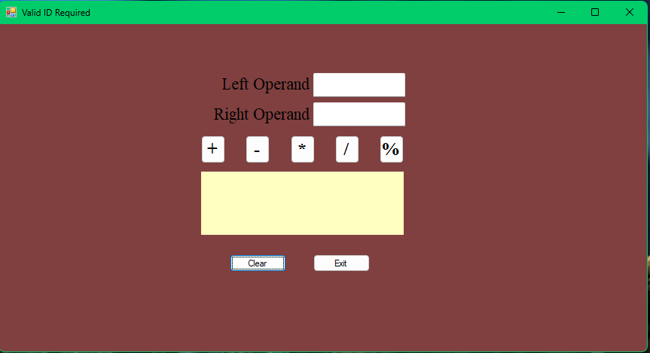
Screenshot 4: show error when missing number in textbox:
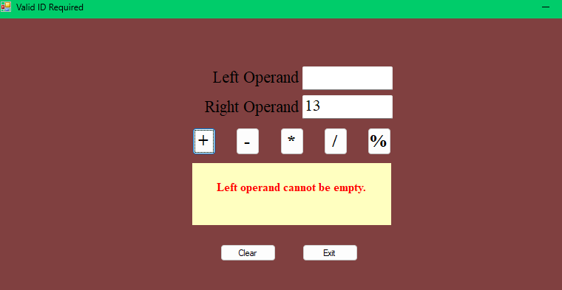

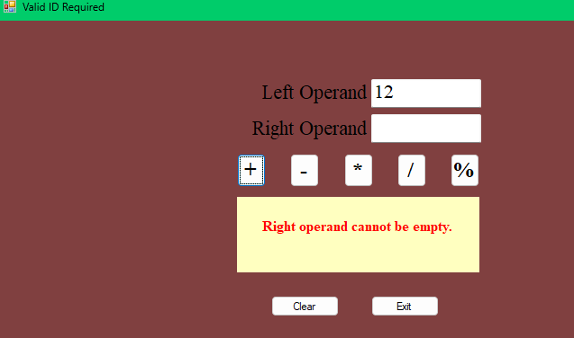

Screenshot 5: show error with letters in textbox:
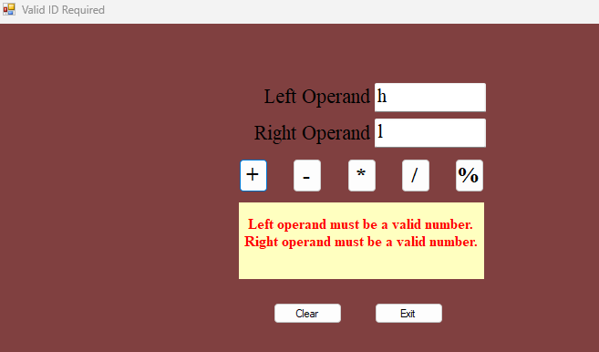

Screenshot 6: divide by 0:
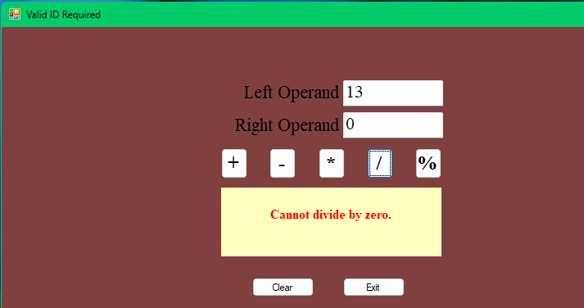

Screenshot 7: put negative numbers in the box and use percentage:
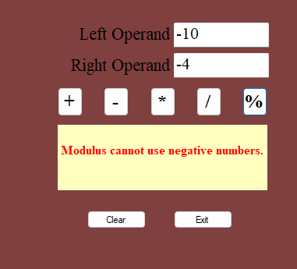

Screenshot 8: show multiple errors at once.

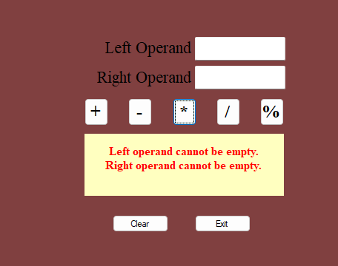

Screenshot 9: unexpected error exception
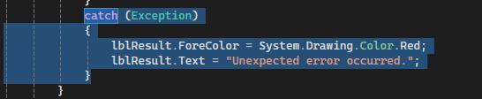

Screenshot 10:





All errors I could possibly make are also shown in each screenshot above.

